Fault Trace Tool User Guide

Table of Contents

Introduction 2

Prerequisites 2

Overview 2

User Interface Elements 3

Version 4

Input Area 4

Fault Study 4

Lightning Study 6

Bookmark 7

Legend 7

Help 8

Background Selector 8

Scalebar 9

Zoom Control 9

Map Area 10

Structures 11

Lightning 11

Fault Indicators 12

Appendix – Example Case Study 13

OPen Browser 13

Enter Time 14

Select Line 15

Select Station 16

Enter Distance 17

Double Ended Fault Location 17

Determine AutoZoom 19

Structure details 19

# Introduction

This guide will equip users to use the Fault Trace Tool. The fault trace tool is a web-based tool for locating faults on a power system system.

# Prerequisites

* You will need an authorized account to access the tool.
* You will need a web-browser (either MS Edge or Google Chrome).

# Overview

To start the tool, open a web browser and navigate to the following address: http://<<servername>>/openftt/

Once the tool is opened, you will be presented with the following user interface:

# User Interface Elements

The user interface consists of 6 main regions: Version, Input Area, Background Selector, Scalebar, Zoom Control, and Map Area. Each of these regions are highlighted in the image below. Subsequent sections will describe the purpose of each area in detail.

## Version



The version area of the map will help users identify which version of the tool they are using. As new features or bug fixes are deployed, the version number will be changed.

## Input Area



The input area of the user interface is where the fault study and lightning study parameters are entered. The top of the input area has four tabs: Faults, Lightning, Bookmark, and Help. The tabs are used to enter parameters for a particular study type. The Bookmark tab will create a quick link so that you can directly access (or email) the fault study parameters you have entered. The Help tab shows a link to the help document.

## Fault Study

Click the Faults Tab. This tab helps locate the faults along the line selected. Optionally, a quick lightning search can be conducted around the line of interest at the time and window specified.

The workflow should follow this order:

1. Enter the Event Time. The time should be entered in the format MM/DD/YYYY HH:mm:SS.sss in Central Prevailing Time. Where:
   1. MM – Is a two-digit month (eg. January is 01).
   2. DD – Is a two-digit day (eg. The 1st of the month is 01).
   3. YYYY – Is a four-digit year (eg. 2020 is 2020).
   4. HH – Is a two-digit hour (eg. Midnight is 00, 1 PM is 13).
   5. mm – Is a two-digit minute (eg. 5 minutes past the top of the hour is 05).
   6. SS – Is a two-digit second (eg. 3 seconds past the top of the hour is 03).
   7. .sss – Is a three-digit subsecond (eg. .640 is 640 ms past the top of the second).
2. Enter the Time window. The default is 10 ms, but may be changed to as many as 999 ms. The window will be the time before and after the Event Time when lightning is searched around the line.
3. Select a line from the drop-down list.
   1. This will show the line on the map.
   2. This will also populate the station drop-down list with stations near the selected line.
4. Select a station from the drop-down list.
   1. This will highlight the station on the map.
5. Type in the distance to the fault from the selected station.
6. If you want the map to automatically zoom into the fault, then leave “AutoZoom To Fault” checked. If you would prefer to manually zoom to the fault area, then uncheck the “AutoZoom To Fault” option.
7. Click the Locate Fault button.
   1. This will show an X at all locations that match the distance criteria.
   2. If the AutoZoom option is enabled, then the map will zoom to the faulted structure(s).
   3. A list of the nearest structures will be displayed immediately under the input area.
8. For a double ended fault location, repeat steps 2-5 above. New substation/fault pairs will receive new matching colors.
9. To clear the faults, click the Clear Faults button.
10. Optionally, to locate lightning around the selected line, click the “Quick Ltg Search” button. *Note: Clicking the “Clear Faults” button also clears any lightning displayed.

## Lightning Study

Click the Lightning Tab. This tab helps locate lightning around any arbitrary address or point.

The workflow should follow this order:

1. Enter the Start Time. The time should be entered in the format MM/DD/YYYY HH:mm:SS.sss in Central Prevailing Time. Where:
   1. MM – Is a two-digit month (eg. January is 01).
   2. DD – Is a two-digit day (eg. The 1st of the month is 01).
   3. YYYY – Is a four-digit year (eg. 2020 is 2020).
   4. HH – Is a two-digit hour (eg. Midnight is 00, 1 PM is 13).
   5. mm – Is a two-digit minute (eg. 5 minutes past the top of the hour is 05).
   6. SS – Is a two-digit second (eg. 3 seconds past the top of the hour is 03).
   7. .sss – Is a three-digit subsecond (eg. .640 is 640 ms past the top of the second).
2. Enter the Stop Time window. The time should be entered in the same format as described in Step 1.
3. Type in an address or coordinates
   1. If you use an address, type in the address in a single row
      1. Example: 2100 E. Exchange Pl, Tucker, GA
      2. Click on the “Get Coords” button.
   2. If you use coordinates, simply type the latitude and longitude in the Lat/Lon fields.
4. Type in the distance to search from the coordinates/address specified.
5. If you want the map to automatically zoom into the fault, then leave “AutoZoom To Lightning” checked. If you would prefer to manually zoom to the fault area, then uncheck the “AutoZoom To Lightning” option.
6. Click the Locate Lightning button.
   1. This will show a Red X at the point of interest, and an orange circle will show the area searched (specified by the Distance field).
   2. If the AutoZoom option is enabled, then the map will zoom to the lightning study area.
   3. A list of the lightning found will be displayed immediately under the input area.
7. To clear the lightning results, click the Clear Results button.

## Bookmark

Clicking the Bookmark tab will reveal a text box that has a hyperlink which can be copied to your browser, an email, or document for quickly recalling the fault study.

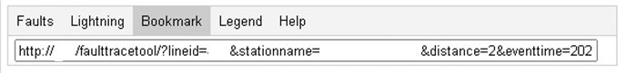

## Legend

Clicking the Legend Tab will show a legend of the symbology for the map.

## Help

Clicking on the Help tab will reveal a hyperlink to the help documentation.

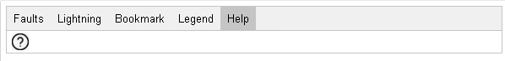

## Background Selector

The background selector enables the user to change between different map backgrounds. The default background is a light grey map. If you click on the map icon, then the map background will be replaced with satellite imagery. Subsequent clicks on the map icon, will toggle between the two available map types. The table below shows the same region with different map backgrounds selected.

|  |  |
| --- | --- |
| Default | Satellite |

## Scalebar

The scalebar shows a visual indication of the size and distance between features on the map. As you zoom into or out of the map display, the scalebar will change accordingly.

## Zoom Control

The zoom control is used to zoom into and out of the map areas. Clicking the + symbol, will zoom into the map. Clicking the – symbol, will zoom out of the map. The map will be centered on the current center of the map after zooming.

If your computer has a scroll mouse, then this can be accomplished by using the scroll wheel on the mouse. The act of pushing the scroll wheel up will zoom into the map. The act of pushing the scroll wheel down will zoom out of the map. The map will zoom with the center of the map being wherever the mouse is pointed.

If your computer is equipped with a track pad, the zoom feature can also be activated using the scroll feature of your track pad. On Macs, this is done with a pinch and zoom gesture. On Windows, this is usually performed by sliding fingers across the surface of the track pad. Usually, scrolling up on the trackpad will result in zooming in. Meanwhile, scrolling down on the trackpad will result in zooming out. The map will zoom with the center of the map being wherever the mouse is pointed.

# Map Area

The map area is where the results of the fault trace tool are displayed.

## Structures

When structures are displayed on the screen as in the sample below, click on a structure to view the distance of that structure to the ends of the selected line:

|  |  |
| --- | --- |
| Line w /Structures | Structure Distance Window |

Distances are supplied both via the selected line and via a straight line. If there are multiple paths between a structure and a substation all distances will be shown.

## Lightning

When lightning is displayed on the screen as in the sample below, the results of the lightning data will show below the input area. Clicking on a lightning event shows the details associated with that lightning strike. The 99% confidence ellipse is shown.

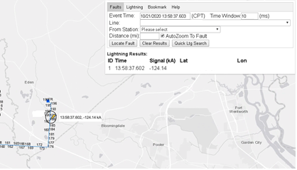  
Lightning Results with Table

Lightning Details Window

## Fault Indicators

When a fault indicator is present on the line, a black circle will appear. When the fault indicator status changes during an event, the color of the circle will be filled in green. If the fault indicator status does not change, the color of the circle will be red. If the fault indicator is not operational, the color will be orange.

|  |  |
| --- | --- |
| Fault Indicator With No Change | Fault Indicator With Change |

Clicking on a fault indicator will reveal the data from the eDNA system. If the indicator has multiple phases being monitored, the data from each phase will be displayed. In the example below, the phases are denoted by P1, P2, and P3. In this case, the indicators did not change status.

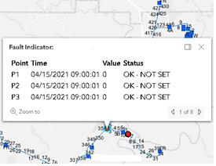  
Fault Indicator Details

# Appendix – Example Case Study

## OPen Browser

Navigate to http://<<Servername>>/openftt/

By default the Faults tab is selected.

## Enter Time

Enter the time of the event. Also enter the time window of the event. The time window will look the specified number of milliseconds before and after the Event Time.

## Select Line

Select a line from the Line Drop Down List. Notice how the selected line is displayed on the map.

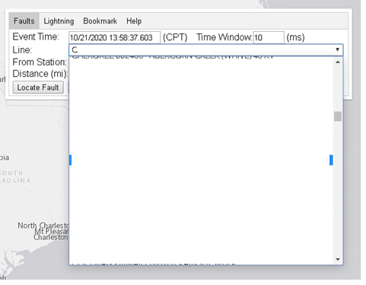

## Select Station

Select a station from the Station Drop Down List. The list has been pre-populated by stations along the line.

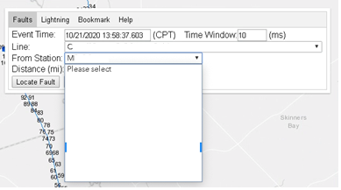

In this case, the C line was chosen. A purple marker appears on the M substation.

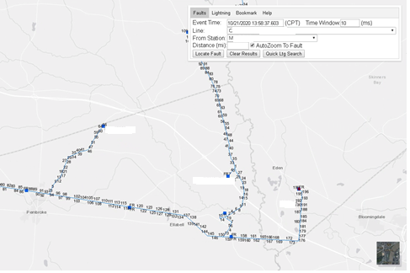

## Enter Distance

Enter the distance from the M station to locate the fault. An X is placed at the relevant location on the map, and are listed in the table below the input area.

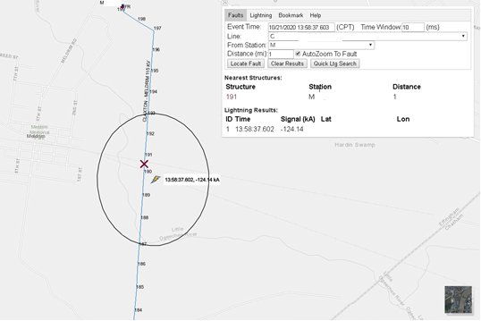

## Double Ended Fault Location

To run a fault study from a different endpoint of the line, select the other station. Enter the distance from that station. Click the Locate Fault button. The new station/fault will appear in a new color (in this case, red). Notice the table in the input area also shows the structure number in the corresponding fault color.

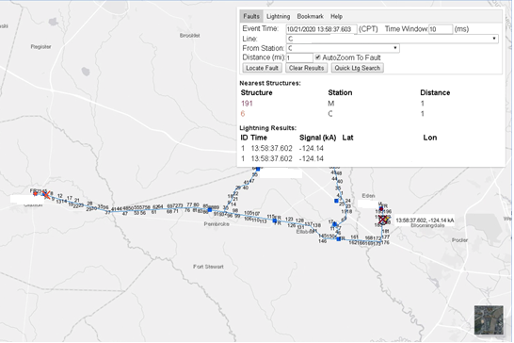

To clear the faults from the map. Click the Clear Results button. Selecting a new line also clears all of the faults and lightning from the map display.

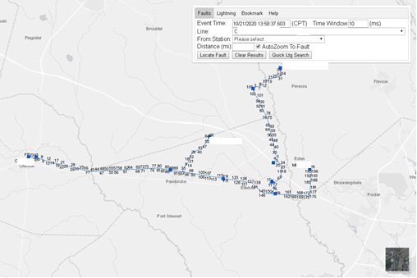

## Determine AutoZoom

When AutoZoom To Fault is enabled, the system will automatically zoom to the structure(s) where the fault has been located. If the feature is disabled, then the map display will remain the same. Examples of both with the same fault parameters are shown below:

|  |  |
| --- | --- |
| AutoZoom To Fault Disabled | AutoZoom To Fault Enabled (Default) |

## Structure details

When the structure is clicked in the map, a popup window appears. The window shows the distance of the structure to the stations near the line.

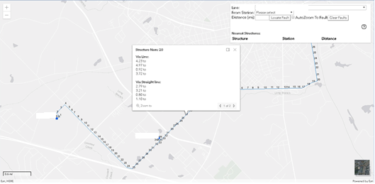

There are several components to the structure detail window. These areas are described below.

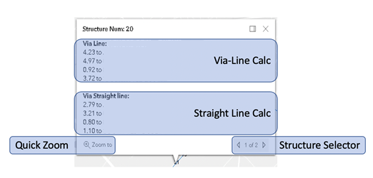

The Via-Line Calc is performed by computing the distance from the structure to the station by following the actual line back to the station. If there are multiple paths, then multiple distances will be reported.

The Straight Line Calc is performed by computing the shortest distance between each of the stations and the selected structure. This does not follow the path of the line.

The Structure Selector appears when there are multiple structures close by. You can navigate between the structures by using the arrows to the left or right of the record counter.

The Quick Zoom button enables you to zoom to the structure currently being viewed.

The window can be closed by selected the X in the upper righthand corner of the window.